Scavenger Hunt: Midsummer Roadside Wildflowers

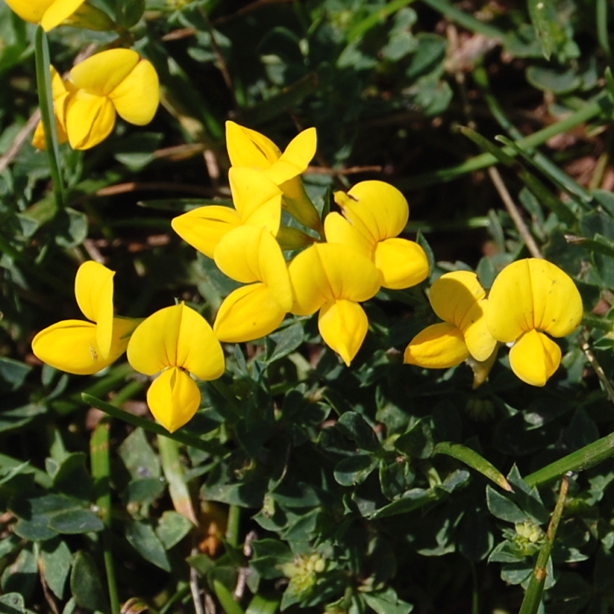  Birdsfoot Trefoil | 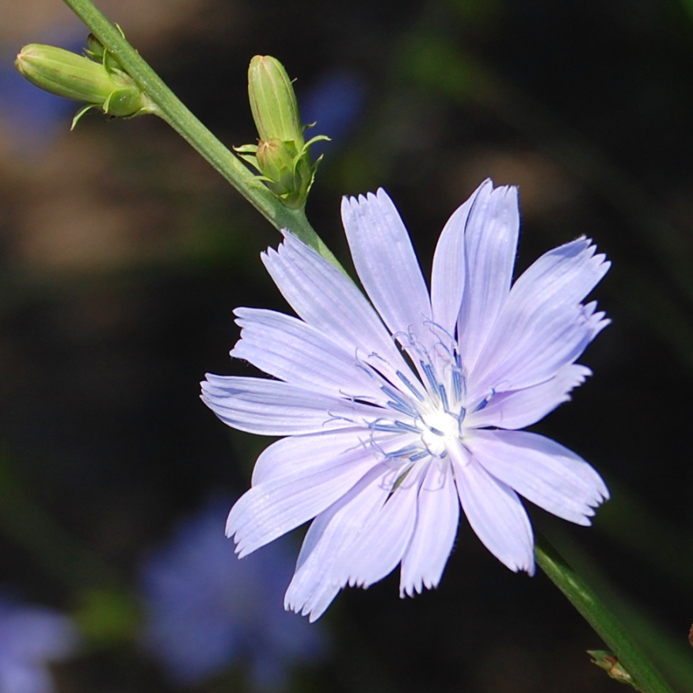  Chicory | 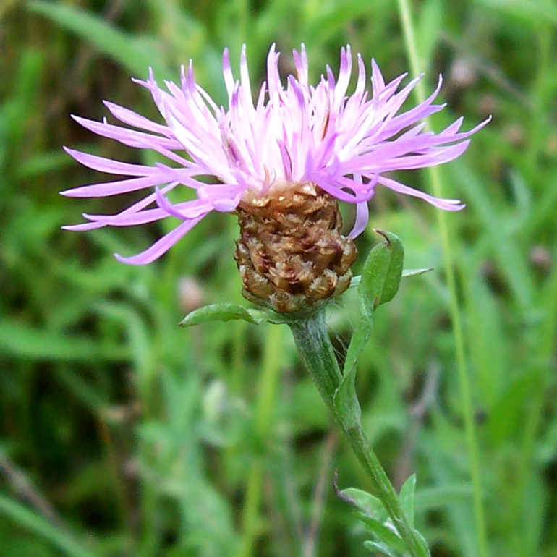  Spotted Knapweed
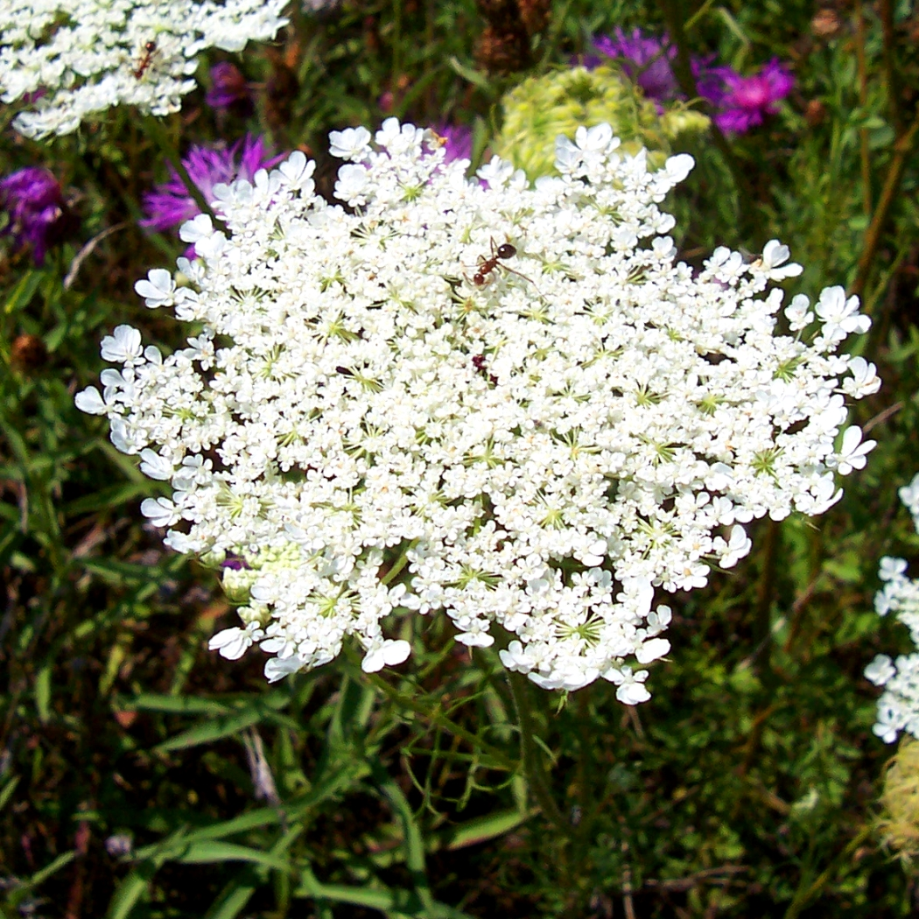  Queen Anne’s Lace | 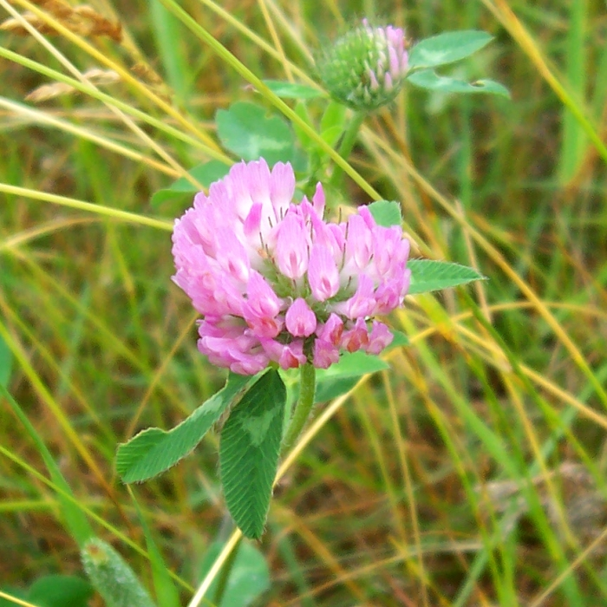  Red Clover | 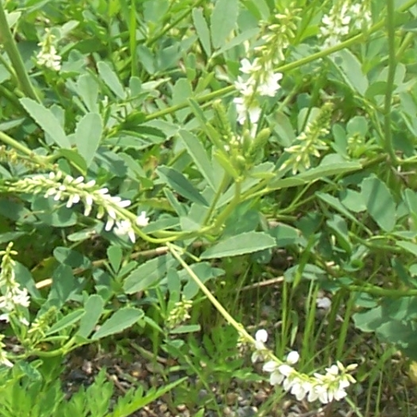  White Sweet Clover
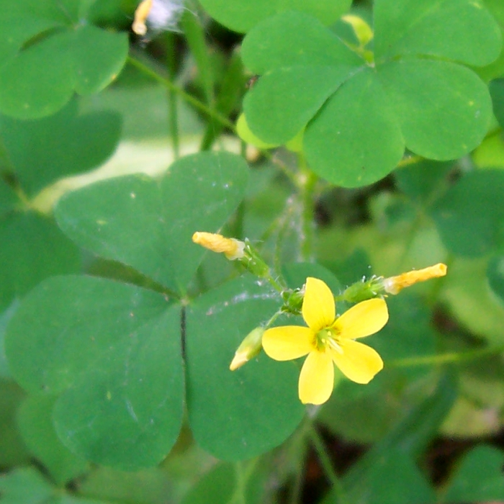  Yellow Wood Sorrel | 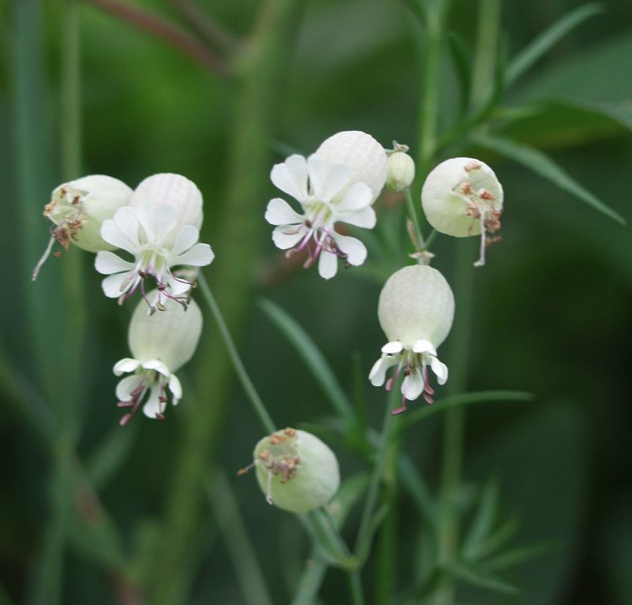  Bladder Campion | 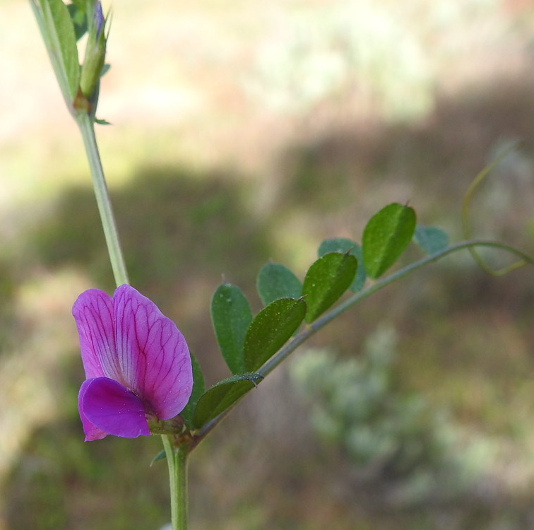  Vetch (many species)
Note: As you may expect due to their weedy, roadside habitats, all of these species – except yellow wood sorrel – are nonnative.

