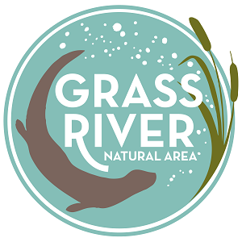
DATES FOR VOLUNTEER EVENTS 2017

ALL-VOLUNTEER TRAINING: SATURDAY APRIL 29, 2017 (9 AM -12:30 PM)
SPRING STREAM MONITORING: SATURDAY MAY 6, 2017 (8 AM-12 PM)
SPRING STEWARDSHIP DAY: SATURDAY MAY 20, 2017 (9 AM- 12 PM)
BENEFIT CONCERT: SATURDAY JUNE 24, 2017 (5 PM – 10 PM)
SUMMER STEWARDSHIP DAY: SATURDAY JULY 22, 2017 (9 AM -12PM)
VOLUNTEER APPRECIATION PARTY: THURSDAY SEPTEMBER 21, 2017 (5 PM- 7 PM)
FALL STREAM MONITORING: SATURDAY OCTOBER 7, 2017 (8 AM- 12PM)
FALL STEWARDSHIP DAY: SATURDAY OCTOBER 21, 2017 (9 AM- 12PM)

