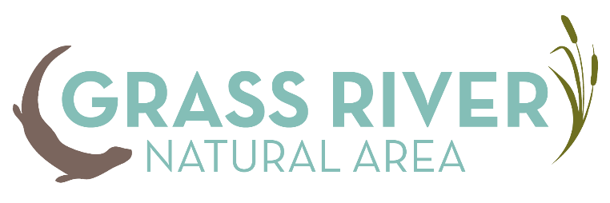
GRNA VOLUNTEER ENRICHMENT DAY
Saturday, April 29
9 am-12:30 pm

8:30 a.m. – 9 a.m. Sign-in and refreshments
9 a.m. – 9:30 a.m. Welcome/Overview of goals and layout of training
Short presentation on GRNA
9:30 – 9:45 a.m. General info about center/property
Safety at GRNA
9:45 -10:00 a.m. Introduction to the handbook
10:00 -11:00 a.m. Breakout training sessions: volunteers may opt in any training they like
Education Volunteers and Docents •Nature education and interpretive training (James Dake, education director at GRNA)
Trail Monitors and Land and Trail Stewards •Tree ID, signs of disease, proper pruning, etc. (Tim Pierce, Land and Facilities Steward at GRNA)
•Invasive species ID (Tom Clement, coordinator at CAKE-CISMA/Antrim County Conservation District)

Conservation Steward •Bird ID and monitoring (Teresa Moore, GRNA bird specialist and leads bird walks every spring at GRNA)
**Additional sessions may be added depending on interest
11:00-11:15 Break/Snack
11:15 – 12:15 Guest speaker: History of Natural Features and Ecology of GRNA (Brad Slaughter, MNFI)
12:15 –12:30 Wrap up and thanks

